Root Cause Analysis of Churn in a Health Subscription App

# Business Problem

Between January and June 2024, the company observed a growing concern: churn rates among users, including paid subscribers, were higher than expected. The leadership team requested a deep-dive analysis to uncover what’s driving user churn and how to reduce it effectively.

# Objective

Conduct a data-driven root cause analysis of churn, with a focus on understanding:  
- Why paid users are leaving  
- What behaviors distinguish churned users from retained ones  
- Which parts of the user journey may be broken  
- What actionable improvements the company can implement

# Key Findings

## 1. User Growth is Flat

From January to June 2024, the app consistently acquired ~583 new users per month, with little to no growth trend. This highlights a stagnant acquisition funnel and raises the urgency to improve retention.

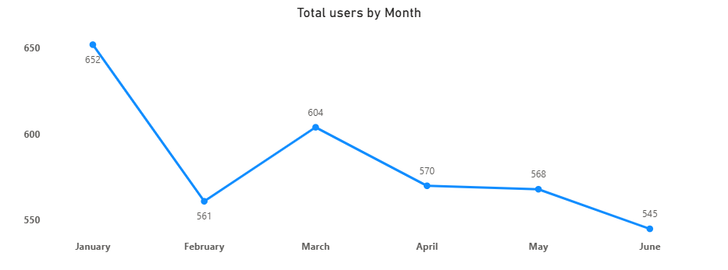

## 2. Churn by Subscription Type and Price

|  |  |
| --- | --- |
| Subscription Type | Churn Rate |
| Trial | 31% |
| Free | 20% |
| Paid | 16% |

- Trial users churn the most, suggesting a weak value proposition or poor early experience.  
- While paid users churn less, their exit still represents lost revenue and dissatisfied customers.

- In paid user who buy 499 plans has lowest churn rate compare to other plans, that show poor Subscription plan planning.

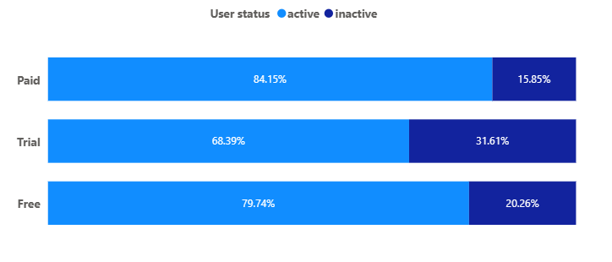

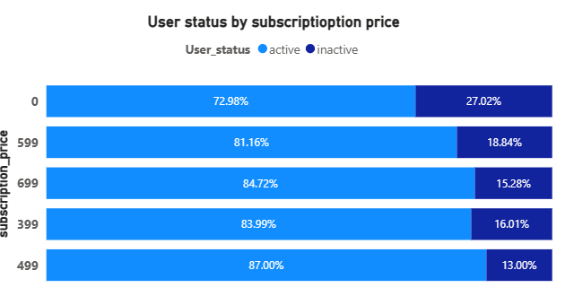

## 3. Engagement Drives Churn

- Coach Interactions:  
 - Churned users averaged 2–3 interactions with their coach  
 - Retained users averaged 3–4 interactions  
- 7-Day Activity:  
 - Churned trial users spent an average of 100 minutes in their first 7 days  
 - Retained users spent around 125 minutes

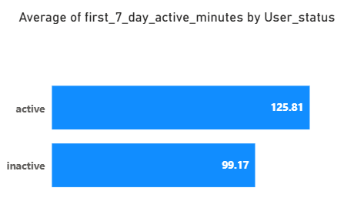

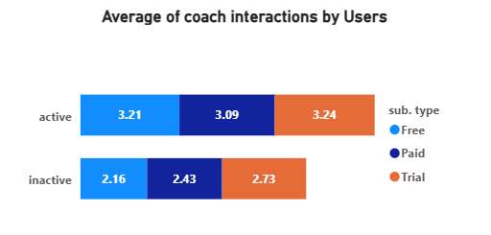

## 4. Onboarding Status Matters

Users who did not complete onboarding were significantly more likely to churn, suggesting that first impressions and guided setup play a crucial role in retention.

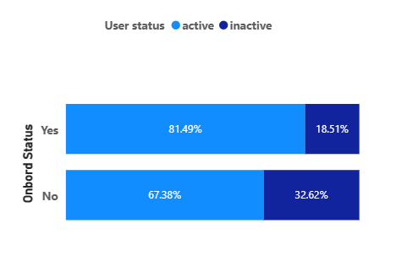

## 5. Average Churn Time

On average, users churned after 65 days, indicating that dissatisfaction builds gradually.

|  |  |
| --- | --- |
| **Row Labels** | **Average of total day spends** |
| Free | 66 |
| Paid | 63 |
| Trial | 65 |
| **Grand Total** | **65** |

## 6. Cancellation Reasons

The most frequently cited reasons for cancellation were:  
- Didn’t use enough  
- Poor experience  
- Switched app  
- Too expensive

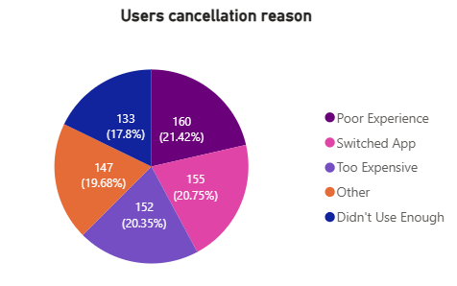

## 7. No Clear Pattern by Age or Gender

Churn rates were relatively uniform across all age groups and genders.

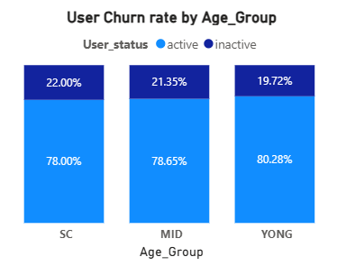

## 8. Diet and Workout Logs – No Major Difference

Usage patterns for diet and workout logging were similar between churned and non-churned users.

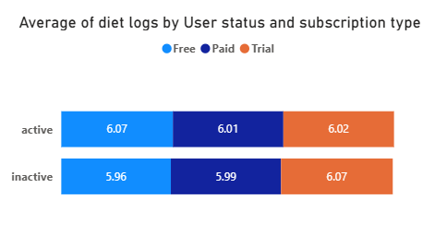

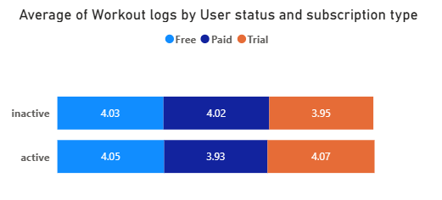

# Root Cause Summary

|  |  |
| --- | --- |
| Factor | Root Cause Insight |
| Early Engagement | Users with low activity in the first 7 days are more likely to churn |
| Coach Interaction | Low interaction levels signal disengagement |
| Onboarding | Users who skip onboarding churn at higher rates |
| Trial Experience | Trial users often fail to convert due to unclear value or poor UX |
| Perceived Value | Cancellation reasons reflect dissatisfaction with pricing and engagement |

# Recommendations

**1. Onboarding & First Impressions**

* Make onboarding a smooth, **mandatory** part of the user journey so that everyone gets familiar with key features from day one.
* Use the onboarding stage to clearly **showcase the value** of coach support, workout tracking, and diet plans.
* Share real **success stories** from existing users to inspire confidence and motivate new users to stay engaged.

**2. Driving Engagement & Retention**

* Introduce fun **daily or weekly challenges** with small rewards and feature top performers within the app to keep users motivated.
* Provide **personalized content and suggestions** that adapt to the user’s gender and age group.
* Enrich diet plans with **simple, healthy recipes** and highlight the benefits of each recipe to make them more practical and appealing.

**3. Building Trust & Credibility**

* Display detailed **coach profiles** including qualifications, specializations, and experience so users know they’re getting expert guidance.
* Feature testimonials and positive feedback from long-term users to reassure new and hesitant members.

**4. Pricing & Value Proposition**

* Review the **current subscription plans**.
* Address price-related churn by offering **targeted discounts** to users who are showing signs of leaving.

**5. User Acquisition & Marketing**

* Launch a **‘Refer and Earn’ program** to encourage satisfied users to bring in friends and family.
* Partner with **influencers or well-known personalities** to raise brand awareness and attract a wider audience.
* Run a **marketing campaign** to communicate recent improvements to the app, coach features, and competitive pricing.

# Appendix: Data Preparation & Modifications

This section documents the data cleaning and transformation steps performed before analysis. These steps ensure that the dataset is accurate, consistent, and aligned with the analysis goals.

1. Added 'age_group' column:  
    - Young = Age ≤ 25 years  
    - Mid = Age 26–40 years  
    - SC = Age ≥ 41 years
2. Added 'total_days_spent' column: Calculated the number of days between 'joined_date' and 'churn_date' for churned users.
3. Corrected spelling mistakes and inconsistencies in categorical columns (e.g., 'couch' → 'coach').